300W LED Lmaging lamp

IP65 Lmaging Lamp

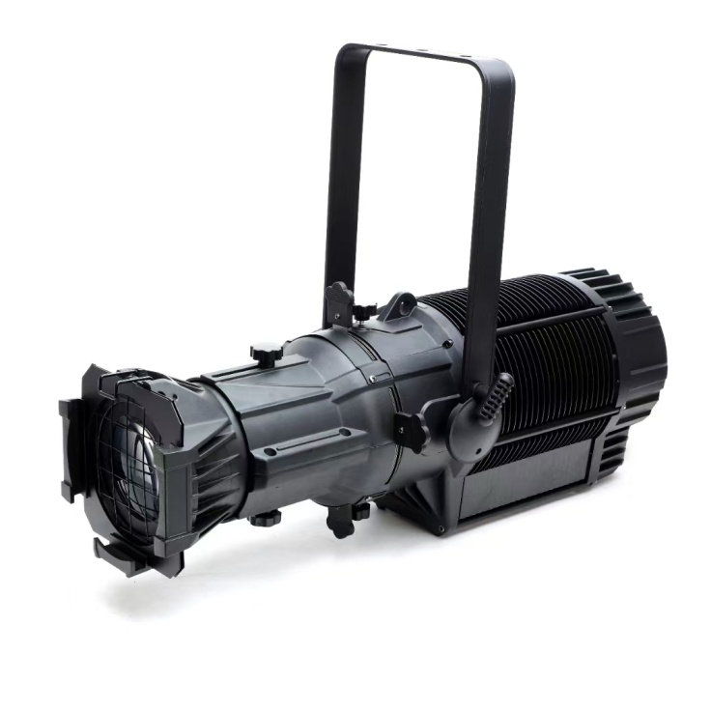

READ CAREFULLY BEFORE USING

Notice: because the policy of improve the products quality of our company. Maybe some data in the instructions will change in future. By that time, we won’t inform you about the changed matters. The-One company reserve the right of changing correlative specification when improve the products. Publisher of the instruction will not responsible for veracity of information and some correlative results caused by this information.

- SAFETY INSTRUCTIONS

Thank you for using the stage lighting produced by our company. In order to ensure the correct and safe installation, use and maintenance of this product, you must read this manual and operate in accordance with the content of this manual: The company does not assume any responsibility for lamp damage, property damage or personal injury caused by maintenance.
Please keep this manual properly in case you need it from time to time.

Safety warning

To ensure your safety and correct use of lamps. Please read the following safety tips carefully before use to avoid unnecessary failures and injuries.
1. This lamp belongs to Class I protection equipment, so the lamp must be well grounded. Power connections must be made by professionals.
2. Make sure that the voltage used is not higher or lower than the value specified in the instruction manual.
3. Confirm that the power cord is not cut or damaged by a sharp blade.
4. Be sure to disconnect the power supply when the lamp is not in use or before cleaning.
5. Only the plug is allowed to connect the power cord. When pulling out the plug, please do not pull the power cord forcibly.
The following points have to be considered during the inspection:
- All screws for installing the devices or parts of the device have to be tightly connected and must not be corroded.
- There must not be any deformations on the housing, color lenses, fixations and installation spots (ceiling, suspension, trussing).
- Mechanically moved parts must not show any traces of wearing and must not rotate with unbalances.
- The electric power supply cables must not show any damage, material fatigue or sediments.
Further instructions depending on the installation spot and usage have to be adhered by a skilled installer and any safety problems have to be removed.


In order to make the lights in good condition and extend the life time, we suggest a regular cleaning to the lights.
- Clean the inside and outside lens each week to avoid the weakness of the lights due to accumulation of dust.
- Clean the fan each week.
- A detailed electric check by approved electrical engineer each three month, make sure that the circuit contacts are in good condition, prevent the poor contact of circuit from overheating.
We recommend a frequent cleaning of the device. Please use a moist, lint-free cloth. Never use alcohol solvents.
There are no serviceable parts inside the device. Please refer to the instructions under “Installation instructions”.
Should you need any spare parts, please order genuine parts from your local dealer.

7.UNPACKING
300W LED Imaging light which features high brightness and stability. Please carefully unpack it when you receive the fixture and check whether it is damaged during the transportation. And please check whether the following items are included inside the box:

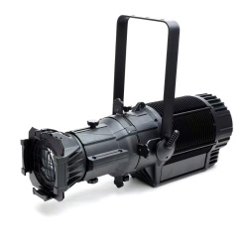

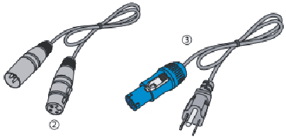

1 2

6. Be careful during the installation of the lamp and avoid touching the bare wires, otherwise you will suffer a fatal electric shock.
7. Do not look directly at the light source when the lamp is in use, otherwise your eyes will be hurt.
8. When selecting the installation location, please make sure that the lamp is not exposed to extreme heat, humidity or dust. The distance between th
lamp and the illuminated object must exceed 0.5 meters. Make sure that there are no flammable and explosive materials within 0.5 meters.
9. When installing the lamp, the fixing screws must be firm, with safety cables, and regular inspections.
10. Please use appropriate and safe wires to connect the lamps.
11. The rotating parts of the lamp and the external and pasted accessories must be checked regularly. If there is any looseness, the shaking should be reinforced in time to prevent accidents.
12. Please operate after familiarizing with the function of the lamp. Most of the damage to the lamps is caused by improper operation.
13. Please do not modify the lamps at will. Doing so may cause short circuit, burning, electric shock, etc.

3:Menu
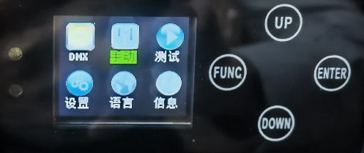

The unlock password for the display screen is as follows: Press (FUNC) first, then press (ENTER), and repeat this process three times.
4:DMX CONTROL CHANNEL1
 | Functional specifications
1CH | Total dimming | 0-255,from dark to bright
2CH | Stroboscopic | 0-255,From slow to fast
3CH | R dimming | Linear dimming from 0-255,from dark to bright
4CH | G dimming | Linear dimming from 0-255,from dark to bright
5CH | B dimming | Linear dimming from 0-255,from dark to bright
6CH | A dimming | Linear dimming from 0-255,from dark to bright
7CH | L dimming | Linear dimming from 0-255,from dark to bright
8CH | Mixed color | (0-255) Divide 8 colors equally
9CH | built-in program | (0-20) built-in program, When the value is greater than 20, the built-in programs are evenly allocated
10CH | Built-in program speed | 0-255 is slow up, 0 is the fastest.

5. Display window function comparison table
NO | Menu | Functional specifications
1 | DMX-Addr-001 | DMX address 001-512
2 | Rotary-ADJ | /
3 | Key-ADJ | Dimmer by manual
4 | Strobe-000 | Strobe function from slow to fast 001-255
5 | Focus | 000-255 Light spot from small to large
5 | DMX Keep | Keep dmx date on/off for optional
6 | Display rotate | Display rotation on/off for optional
7 | LANGUAGE | Language selection EN/CH
8 | RESET | Reset switch
2.Specification
Rated power: 300W
Input voltage: AC110V-240V/50-60HZ
LED Color: RGBAL(5IN1)
Zomm Function:Auto zoom,Beam Angle：5°，10°，14°，19°， 26°36°，50°。
Dimming Curve: 4kinds
Dimming Frequency,500HZ
Strobe:1-25times/sec.
Housing : Die-casting Aluminum
Technology: HIGH-quality optical system,glass reflector
Touch screen: LCD with touch screen
Control Protocol: RDM/DMX
Control System: DMX,Auto run and Master/Slave
DMX Channels: 10CH
Working Temperature:-30 - 55°C
Cooling System: Fan-less no noise
IP Grade: IP65 waterproof
Net Weight: 12KG
Gross Weight: 13.5KG
Packing size: 680*200*250mm

